

**Tech Saksham**

Case Study Report

Data Analytics with Power BI

**“Supply Chain Analysis of Inventories”**

**“SENGUNTHAR ARTS AND SCIENCE COLLEGE, TIRUCHENCODE”**

|  |  |
| --- | --- |
| **NM ID** | **NAME** |
| 92DAC15BD4AA406BFF041DF3FB0E31A5 | VIKASINI.M |

|  |  |  |
| --- | --- | --- |
|  |  | **Trainer Name :** R.UMAMAHESHWARI  **Master Name:** R.UMAMAHESHWARI |
|  |  |
|  |  |

**ABSTRACT**

Power Bi, a fictional company specializing in renewable energy solutions, faces unique challenges and opportunities in managing its inventory due to the dynamic nature of its industry. The analysis explores various aspects of inventory management, including procurement, production, distribution, and demand forecasting, with a focus on optimizing efficiency and minimizing costs while meeting customer demand. Special attention is given to the integration of renewable energy components into the inventory management process, considering factors such as seasonality, technological advancements, and regulatory requirements. Additionally, the paper discusses the role of advanced technologies, such as block chain and artificial intelligence, in enhancing inventory visibility, traceability, and decision-making within the Power bi supply chain. Through a combination of theoretical frameworks and practical insights, this analysis aims to provide valuable guidance for Power bi and other renewable energy companies seeking to optimize their inventory management practices and achieve sustainable competitive advantage in the evolving marketplace.

Top of Form

**INDEX**

|  |  |  |
| --- | --- | --- |
| **S. No.** | **Table of Contents** | **Page No.** |
| 1 | Chapter 1: Introduction | 1 |
| 2 | Chapter 2: Services and Tools Required | 3 |
| 3 | Chapter 3: Project Architecture | 5 |
| 4 | Chapter 4: Modeling and Result | 6 |
| 5 | Conclusion | 12 |
| 6 | Future Scope | 13 |
| 7 | Link | 14 |

**CHAPTER 1**

**INTRODUCTION**

**Problem Statement**

**Background:** A company operates within a complex supply chain environment, sourcing raw materials from multiple suppliers, producing goods through various manufacturing processes, and distributing finished products to customers. Effective management of inventory throughout the supply chain is crucial for minimizing costs, optimizing production, and meeting customer demand.

**Objective:** The objective of this project is to develop a comprehensive supply chain inventory analysis solution using Power BI. The solution will enable stakeholders to gain insights into inventory levels, identify trends, forecast demand, and optimize inventory management strategies.

**Proposed Solution**

**Solution Overview:** The proposed solution for Supply Chain Inventory Analysis using Power BI encompasses data integration, visualization, forecasting, supplier performance analysis, and inventory optimization. It aims to provide stakeholders with actionable insights to improve inventory management, reduce costs, and enhance customer satisfaction.

**Feature: Interactive Dashboards:** Users should be able to filter data based on various parameters such as product category, location, and time period.

Inventory KPIs: Include key performance indicators (KPIs) related to inventory management such as inventory turnover, days of inventory, fill rates, and stock out rates.

**Demand Forecasting:** Integrate demand forecasting models to predict future inventory requirements based on historical sales data and external factors such as seasonality, promotions, and market trends.

**Advantages**

**Mobile Accessibility:** Power BI provides mobile apps for iOS, Android, and Windows devices, allowing users to access inventory dashboards and reports from anywhere, anytime.

**Customization and Extensibility:** Power BI offers extensive customization options, allowing users to tailor dashboards, reports, and visualizations to their specific needs.

**Integration with Microsoft Ecosystem:** As part of the Microsoft ecosystem, Power BI seamlessly integrates with other Microsoft products and services such as Excel, SharePoint, Azure, and Dynamics 365.

**Scope**

* Applying inventory optimization techniques such as economic order quantity (EOQ), safety stock calculations, and ABC analysis.
* Conducting scenario analysis to evaluate the impact of different inventory management strategies on costs and service levels.
* Implementing alerts and notifications to notify stakeholders of critical inventory events such as stock outs, excess inventory levels, or deviations from forecasted demand.

**CHAPTER 2**

**SERVICES AND TOOLS REQUIRED**

**Services Used**

**Power BI Desktop:** Power BI Desktop is used for data preparation, modeling, and report/dashboard creation.It allows users to connect to multiple data sources, transform data using Power Query, create data models, and design interactive visualizations.

**Power BI Service (Power BI Cloud):** Power BI Service is the cloud-based platform for publishing, sharing, and collaborating on Power BI reports and dashboards.It enables users to publish reports created in Power BI Desktop to the cloud, schedule data refreshes, and share reports with stakeholders.

**Power Query:** Power Query is used for data transformation and cleansing within Power BI Desktop. It allows users to connect to various data sources, apply transformations (e.g., filtering, merging, pivoting), and clean data for analysis.

**Tools and Software used**

**Tools**:

**Power BI**: The main tool for this project is Power BI, which will be used to create interactive dashboards for real-time data visualization.

**Power Query**: This is a data connection technology that enables you to discover, connect, combine, and refine data across a wide variety of sources.

**Software Requirements**:

**Power BI Desktop**: This is a Windows application that you can use to create reports and publish them to Power BI.

**Power BI Service**: This is an online SaaS (Software as a Service) service that you use to publish reports, create new dashboards, and share insights.

**Power BI Mobile**: This is a mobile application that you can use to access your reports and dashboards on the go.

**CHAPTER 3**

**PROJECT ARCHITECTURE**

**Architecture**

**USER FRONTEND BACKEND**

|  |  |  |
| --- | --- | --- |
|  | **HTML 5** | **NODEJS 14.0**  **Database** |

Here’s a high-level architecture for the project:

**Data Sources:** Inventory data is sourced from various systems within the supply chain, including ERP systems, manufacturing databases, sales records, and external data sources such as supplier portals and market databases.

**Data Integration:** Power BI connects to these data sources using connectors, APIs, or direct database connections to extract inventory data.

**Data Modeling:** Within Power BI Desktop, a data model is created to establish relationships between different inventory data tables.

**Analysis and Visualization:** Power BI Desktop is used to design interactive dashboards and reports that visualize inventory data, trends, and performance metrics.

**Forecasting and Optimization:** Forecasting models and optimization techniques are implemented using Power BI's built-in capabilities or integrated with external tools such as R or Python.

**Power BI Service (Cloud):** Power BI reports and dashboards created in Power BI Desktop are published to Power BI Service, the cloud-based platform for sharing and collaboration.

**Data Gateway:** For on-premises data sources, Power BI Data Gateway is deployed to establish secure connectivity between Power BI Service and on-premises databases.

**Power BI Mobile App:** Power BI Mobile App provides access to inventory reports and dashboards on mobile devices, enabling users to view, interact with, and share insights while on the go.

**CHAPTER 4**

**MODELING AND RESULT**

**Manage relationship**

The “disp” file will be used as the main connector as it contains most key identifier (account id, client id and disp id) which can be use to relates the 8 data files together. The “district” file is use to link the client profile geographically with “district id”.

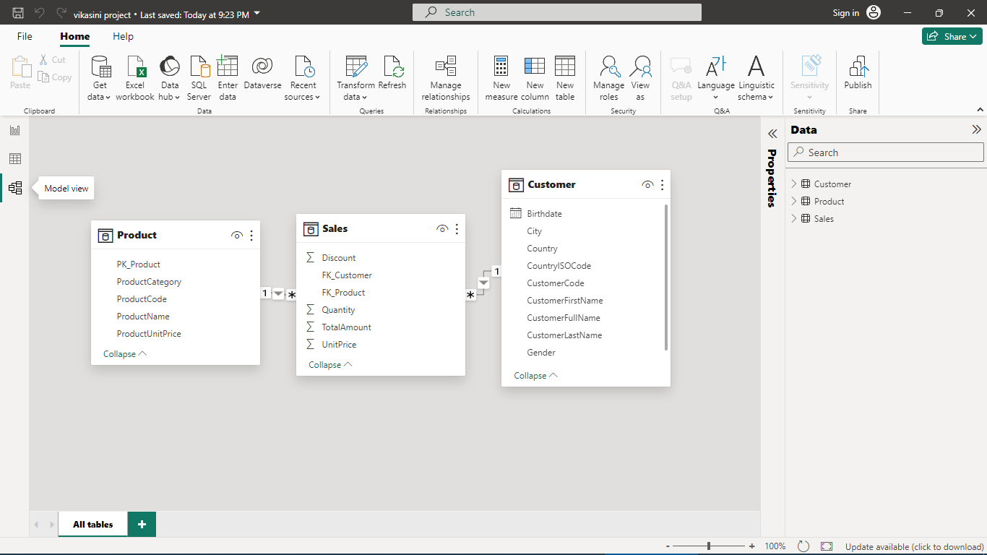

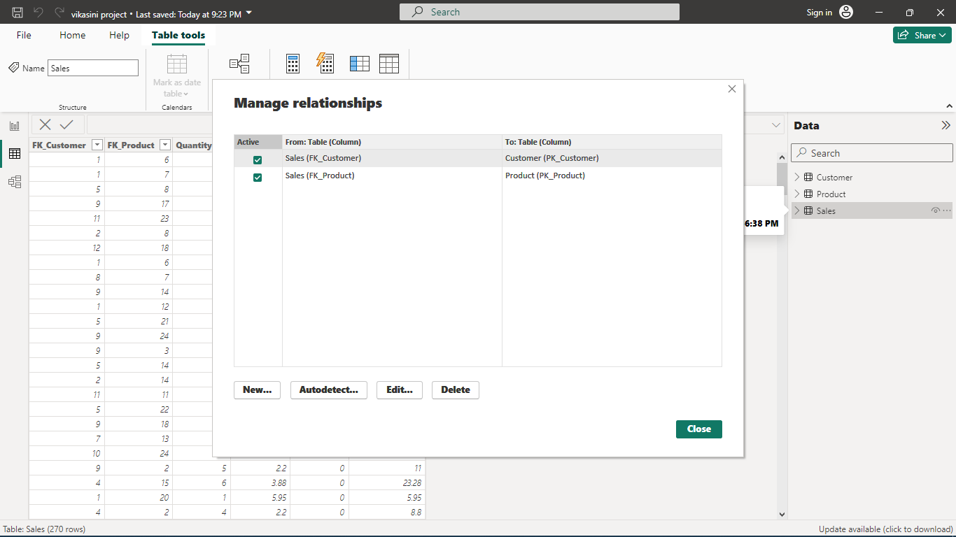

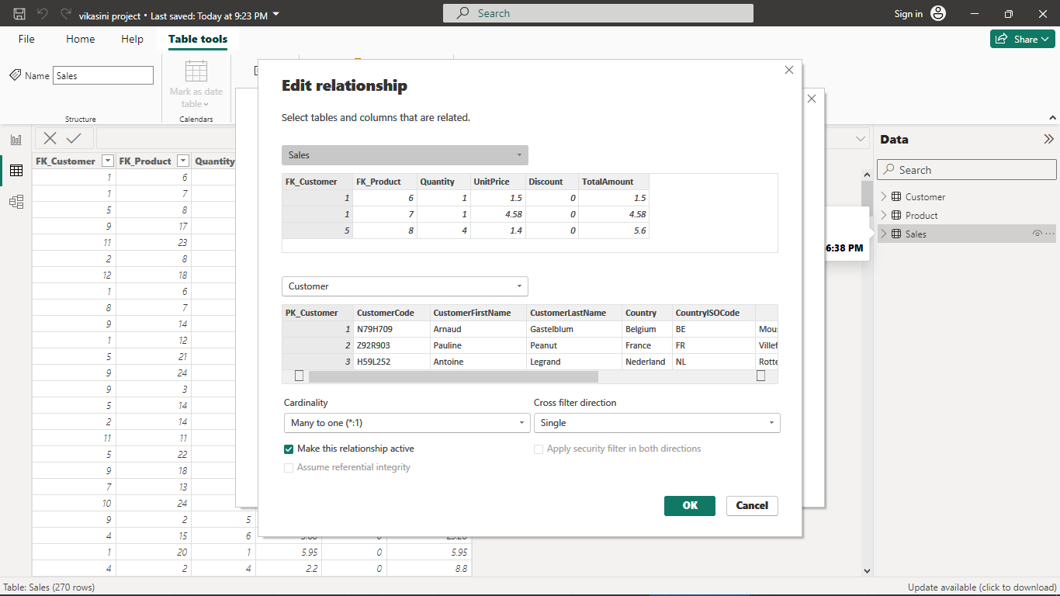

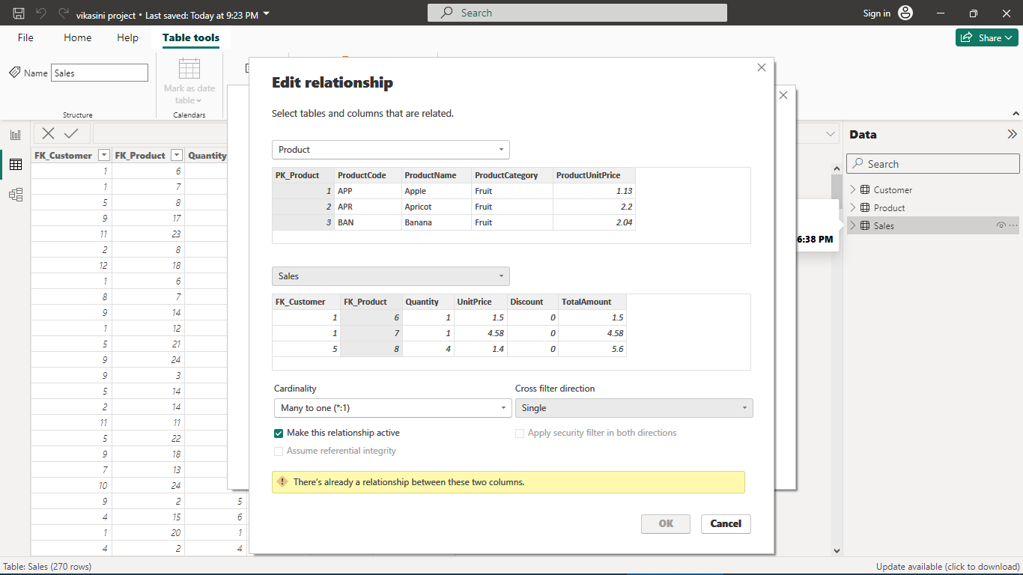

**Modeling for Gender and Age data**

Notice that the Gender and age of the client are missing from the data. These can be formulated from the birth number YYMMDD where at months (the 3rd and 4th digits) greater than 50 means that client is a Female. We can create a column for Gender.

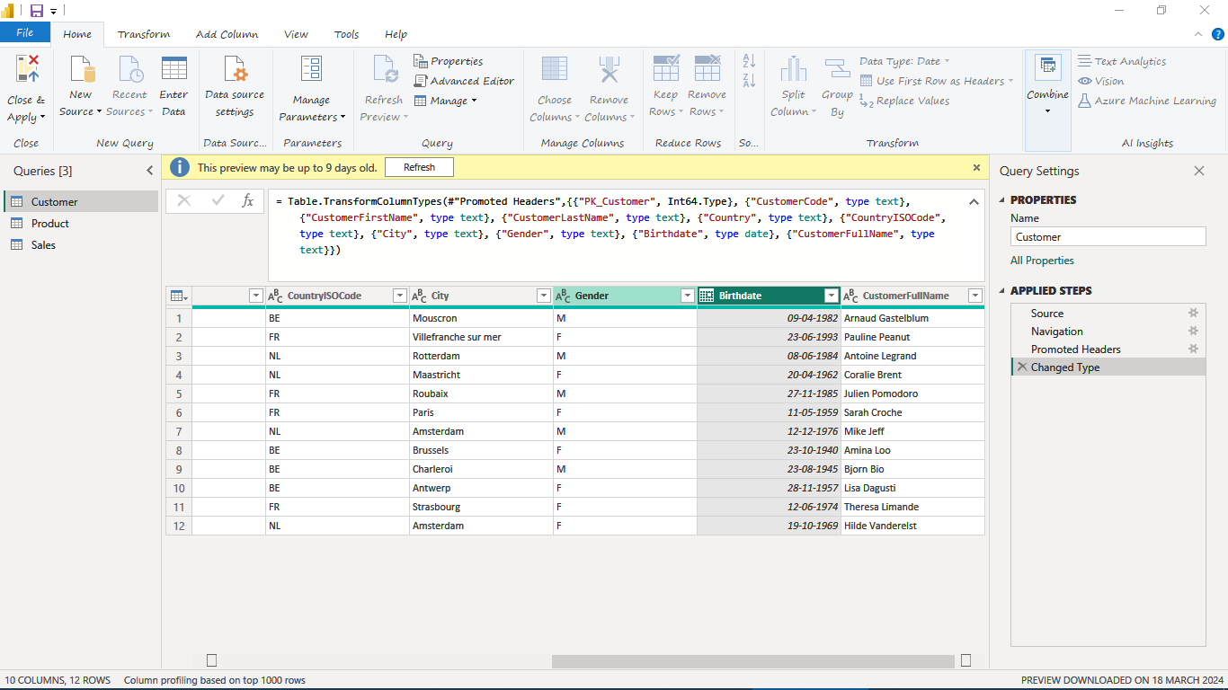

**Replacing values**

Set some fields to English for easy understanding, we replace values to English with the Power Query Editor.

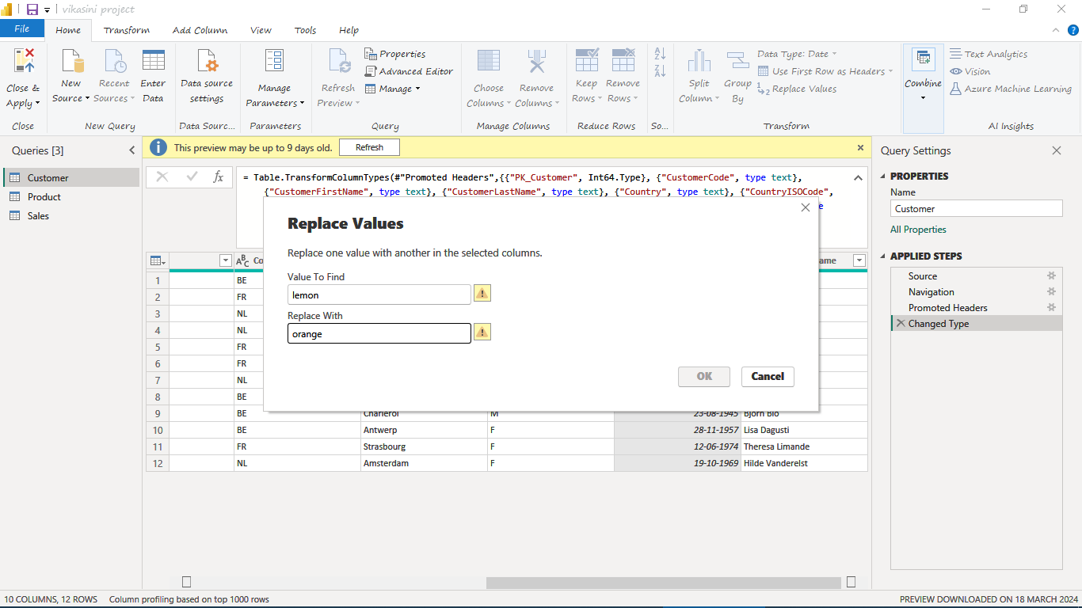

Changing the order of Region name at Power Query

Duplicate the “district /region” then split column using space as delimiter.

Then merge column by Region and direction. Refer to applied steps for details.

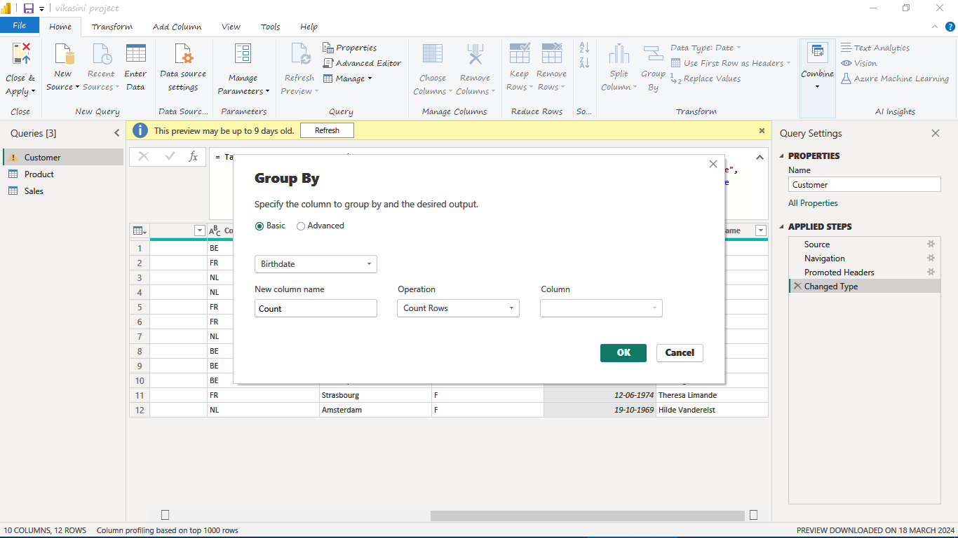

**Dashboard**

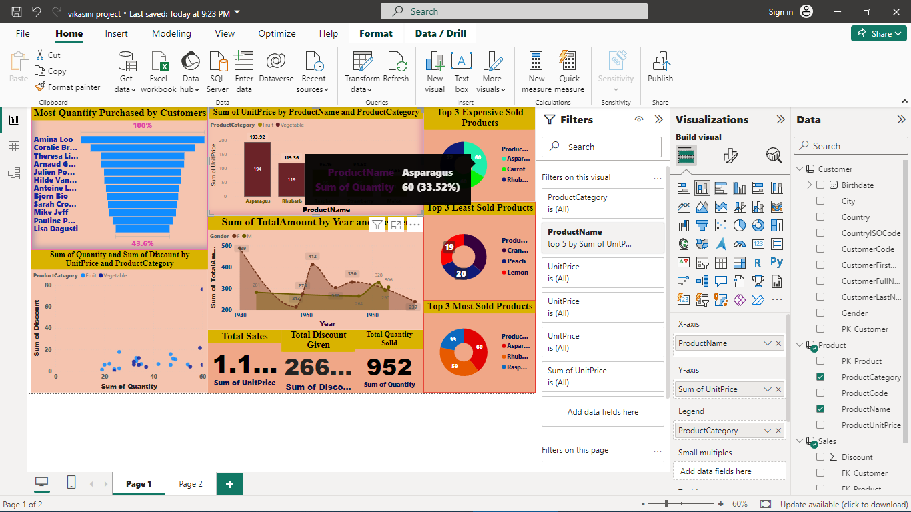

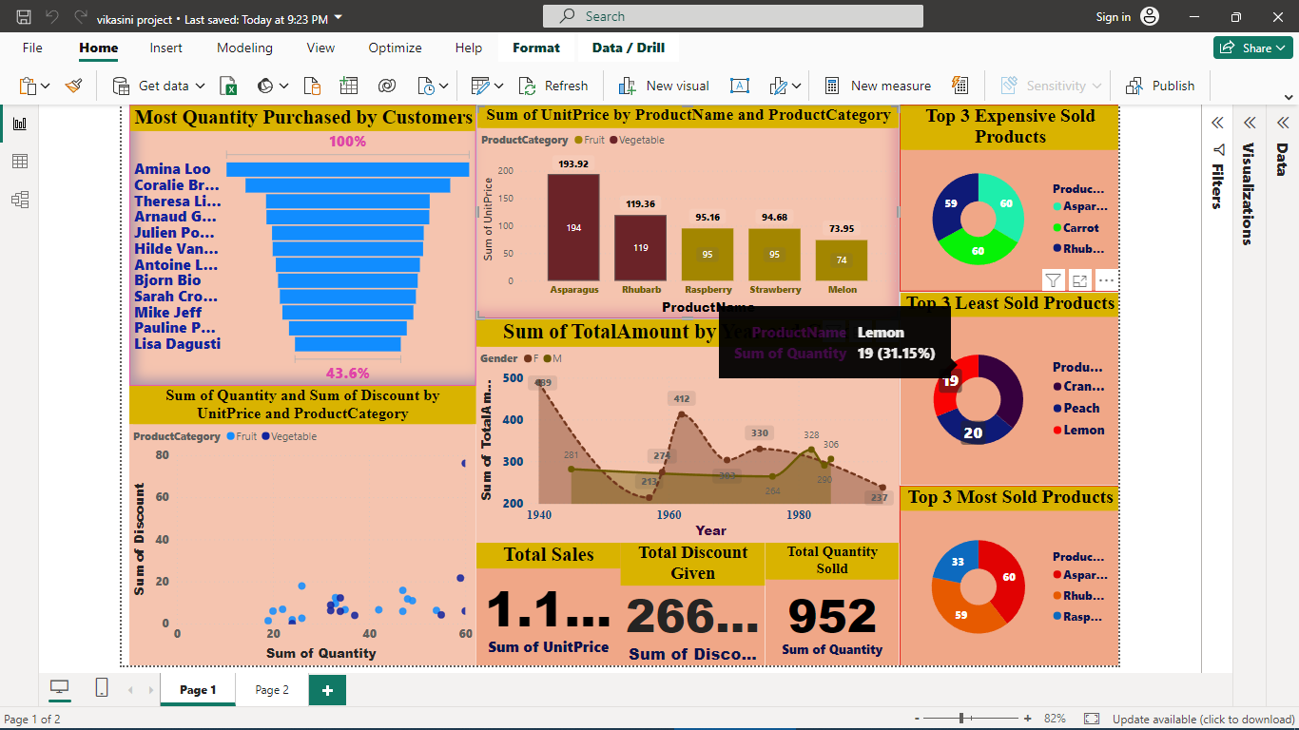

**CONCLUSION**

In conclusion, harnessing the power of supply chain analysis through tools like Power BI offers a transformative approach to inventory management. Power BI provides a dynamic platform to visualize, analysis, and interpret inventory data, enabling organizations to derive actionable insights and drive strategic decision-making across the supply chain. In essence, by leveraging Power BI for supply chain analysis of inventories, organizations can unlock new levels of operational efficiency, agility, and competitiveness. The ability to visualize, analyse, and act on inventory data in real-time empowers businesses to optimize inventory management practices, drive cost savings, and deliver superior value to customers. As organizations continue to navigate the complexities of global supply chains, Power BI emerges as a strategic enabler for achieving supply chain excellence and sustained business success.

**FUTURE SCOPE**

**AI and Machine Learning Integration:** Future iterations of Power BI can incorporate advanced AI and machine learning algorithms to enhance predictive analytics capabilities. By leveraging AI-driven demand forecasting and optimization algorithms, Power BI can enable automated decision-making and prescriptive recommendations for inventory management, leading to greater efficiency and cost savings.

**Block chain for Supply Chain Transparency:** Power BI can integrate block chain technology to provide greater transparency and traceability across the supply chain. By leveraging block chain's immutable ledger capabilities, Power BI can enable end-to-end visibility of inventory movements, ensuring authenticity, compliance, and accountability in supply chain operations.

**IoT-enabled Inventory Tracking:** Power BI can leverage IoT sensors and devices for real-time inventory tracking and monitoring. By integrating IoT data streams into Power BI dashboards, businesses can gain granular insights into inventory levels, location tracking, and environmental conditions, enabling proactive inventory management and risk mitigation.

**Supply Chain Collaboration Platforms:** Future versions of Power BI can serve as collaborative platforms for supply chain stakeholders, enabling seamless communication, data sharing, and decision-making. By facilitating real-time collaboration and information exchange, Power BI can enhance supply chain resilience, agility, and responsiveness to changing market dynamics.

**Advanced Visualization and Simulation:** Power BI can evolve to offer advanced visualization and simulation capabilities for scenario planning and optimization. By simulating various inventory management strategies and scenarios, Power BI can help businesses identify the most cost-effective and risk-averse approaches to inventory management, driving continuous improvement and innovation.

**Integration with Emerging Technologies:** Power BI can continue to integrate with emerging technologies such as 5G connectivity, edge computing, and augmented reality (AR) for enhanced inventory management capabilities. By leveraging these technologies, Power BI can enable real-time data processing, immersive visualization, and remote monitoring of inventory operations, empowering businesses to operate more efficiently and competitively in the digital age.

**LINK**

**https://github.com/VIKASINI-M/SUPPLY-CHAIN-ANALYSIS-FOR-INVENTORIES**